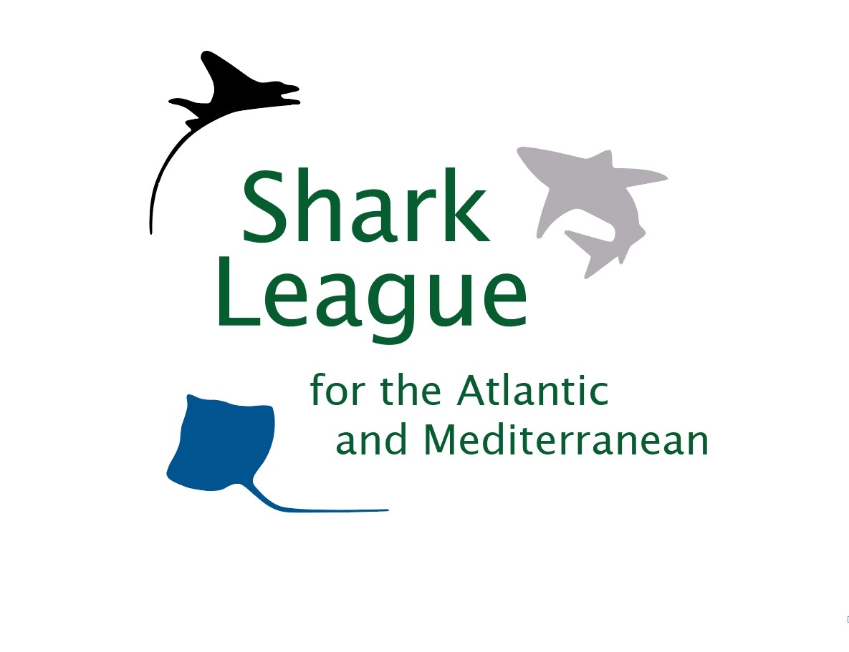
PRESS RELEASE
Endangered Mako Sharks Get A Break
International fishery managers agree to historic yet potentially short-term North Atlantic ban
Madrid, Spain. November 23, 2021. Conservationists are heralding a hard-fought ban on retention of North Atlantic shortfin mako sharks adopted today by the International Commission for the Conservation of Atlantic Tunas (ICCAT), as a first step toward reversing the decline of the seriously overfished population. The ban forms the core of a long-term international rebuilding plan, the first in the world for this exceptionally valuable, globally threatened species. ICCAT fishery managers agreed that, in 2022 and 2023, all retention of North Atlantic shortfin makos will be prohibited, an action that ICCAT scientists have advised since 2017. The EU – which has long taken the lion’s share of mako catch – insisted, however, on including a complicated formula that may offer a way for some Parties to resume landings after the reprieve.

“We congratulate Canada, the UK, Senegal, and Gabon, for leading the charge to secure this historic, science-based protection for endangered shortfin mako sharks,” said Shannon Arnold, Marine Program Coordinator for Ecology Action Centre. “We celebrate this critical step today, mindful that the fight to bolster it begins tomorrow. It is crystal clear from these negotiations that the EU remains focused on reviving exploitation as soon as possible. To prevent shenanigans and backsliding in 2024, we need even more countries at the table fighting back with equal vigor to rebuild the population.”

Scientists have recommended a North Atlantic shortfin mako retention ban as the most effective immediate step toward reversing decline and rebuilding the population over about 50 years. Such a ban has been repeatedly proposed by many countries but competing proposals from the EU and US for continued landings prevented progress until now.

With its vast longline fleet and lax mako management, the EU remains the main threat to recovery. The EU took 74% of the 2020 North Atlantic shortfin mako catch. The EU set its first catch limit this year. Spain’s was grossly exceeded last year.

“At long last, we have the basis for a game-changing rebuilding plan, but it won’t be successful if we take our eyes off the EU and their egregious intent to resume fishing a decade before rebuilding is predicted to begin,” said Ali Hood, Director of Conservation for the Shark Trust. “In this moment, however, we focus on the overwhelming chorus of concern that helped us reach this critical breakthrough. We’re deeply grateful for the ‘voices for makos’ – the continuous calls from conservationists, divers, scientists, aquarists, retailers, and elected representatives to protect this beleaguered shark.”

Prized for meat, fins, and sport, shortfin makos are exceptionally valuable sharks. Slow growth makes them, and closely related longfin makos, exceptionally vulnerable to overfishing. Both of these oceanic species are classified by the IUCN as globally Endangered. Subsequent listings on Appendix II of the Convention on International Trade in Endangered Species (CITES) require Parties to demonstrate that mako exports are sourced from legal, sustainable fisheries.

“We’re pleased that the US has accepted the mako ban that scientists advise and hope that it signals a shift back toward leadership in shark conservation,” said Sonja Fordham, President of Shark Advocates International. ”With all the existing commitments and warnings about the dire status of makos, this win should not have been this hard. We urge all Parties to align their ICCAT and CITES obligations for makos, and strive to augment rather than relax this crucial recovery effort.”

The new measure directs scientists to examine catch trends for longfin makos, which remain unprotected outside US waters. ICCAT has yet to address scientists’ advice to limit South Atlantic shortfin mako catches but did agree to allocate among Parties the total catch limit for South Atlantic blue sharks as soon as next year. An exceptionally popular proposal to strengthen the ICCAT finning ban by prohibiting at-sea removal of fins was once again blocked by Japan.

Media contact: Patricia Roy email: patricia@communicationsinc.co.uk, Tel: +34 696 905 907.

Notes to Editors: The Shark Trust is a UK charity working to safeguard the future of sharks through positive change. Ecology Action Centre promotes sustainable, ocean-based livelihoods, and marine conservation in Canada and internationally. Project AWARE is a global movement for ocean protection powered by a community of adventurers. Shark Advocates International is a project of The Ocean Foundation dedicated to securing science-based policies for sharks and rays. These groups, with support from the Shark Conservation Fund, formed the Shark League of the Atlantic and Mediterranean to advance responsible regional shark and ray conservation policies.

ICCAT’s new measure prohibits fishermen from retaining on board, transhipping, and landing (whole or in part) North Atlantic shortfin makos caught in association with ICCAT fisheries in 2022 and 2023, as a first step toward rebuilding the population. The agreement includes a complicated formula for using interim mortality data to determine if limited retention in some fisheries might be allowed in the near future.

The new measure also directs ICCAT scientists to provide further advice on actions that could reduce mako bycatch and associated mortality.

The Shark League’s “Voices for Makos” site showcases the outpouring of public support for ICCAT protection of North Atlantic shortfin makos.

ICCAT is responsible for conservation of tunas and tuna-like species in the Atlantic Ocean and adjacent seas. ICCAT has 52 Contracting Parties, including the European Union. ICCAT scientists updated the status of Atlantic shortfin mako sharks in 2019.

Countries supporting the science-based North Atlantic mako ban over recent years include Canada, Senegal, the Gambia, Gabon, Panama, Liberia, Guatemala, Angola, El Salvador, Egypt, Norway, Guinea Bissau, Uruguay, Japan, China, and Taiwan.

Countries reporting 2020 catches of North Atlantic makos (Isurus oxyrinchus) include (in order of magnitude): EU (Spain and Portugal), Morocco, US, Venezuela, Mexico, and Trinidad and Tobago.

In 2017, ICCAT mandated that North Atlantic makos brought to boat alive must be carefully released, unless the country had a minimum size limit (at about the length of maturity) or a discard ban (that prevents profit). Dead makos could be still be landed (and sold) by boats under 12 meters, and by larger vessels under certain conditions for monitoring catch and reporting data. Scientists quickly demonstrated that this measure was inadequate to end overfishing, much less rebuild the population. ICCAT has debated a replacement ever since.
Shortfin and longfin makos ranked high for vulnerability to ICCAT fisheries in a 2012 Ecological Risk Assessment of 20 pelagic shark stocks.

